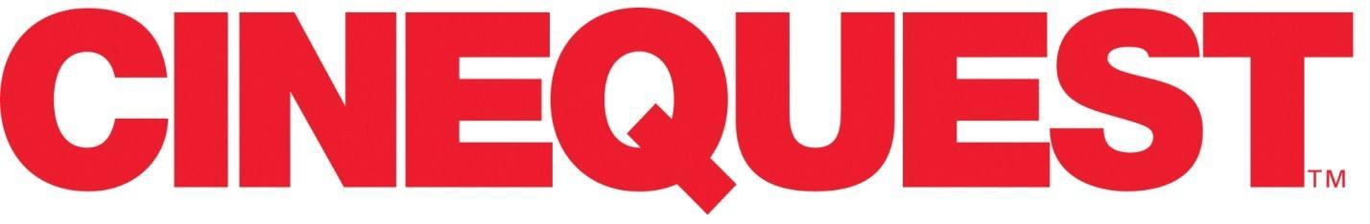
FOR IMMEDIATE RELEASE: Contact: Angela Ostermeier
April 23, 2021 E-mail: publicity@cinequest.org

THAT’S A WRAP!
Cinejoy featuring the Artists & Films of Cinequest
2021 Awards Announcement

April 23, 2021 (Silicon Valley)— Cinequest, reimagined virtually on a proprietary platform as Cinejoy featuring the Artists & Films of Cinequest, wrapped March 30 and presented a groundbreaking lineup of Live Spotlight Events, Live Parties, Red Carpets, and Lounges, plus 199 Showcase Films and Television (111 of which are World & U.S. Premieres) from 55 countries. Cinequest proudly presents the prestigious Award Winners:
MAVERICK SPIRIT AWARDS
Cinequest’s highest award, the Cinequest Maverick Spirit Award, honors those who stand apart from the crowd, creating and innovating from a place of personal yet global vision. Past recipients include Harrison Ford, Neil Gaiman, Nicolas Cage, J.J. Abrams, Alec Baldwin, Rosario Dawson, James Franco, Michael Keaton, Sir Ben Kingsley, Spike Lee, Jennifer Jason Leigh, Sir Ian McKellen, and Gus Van Sant. This year’s recipients are:
- Eddie Izzard
- Sam Neill
- Darren Star
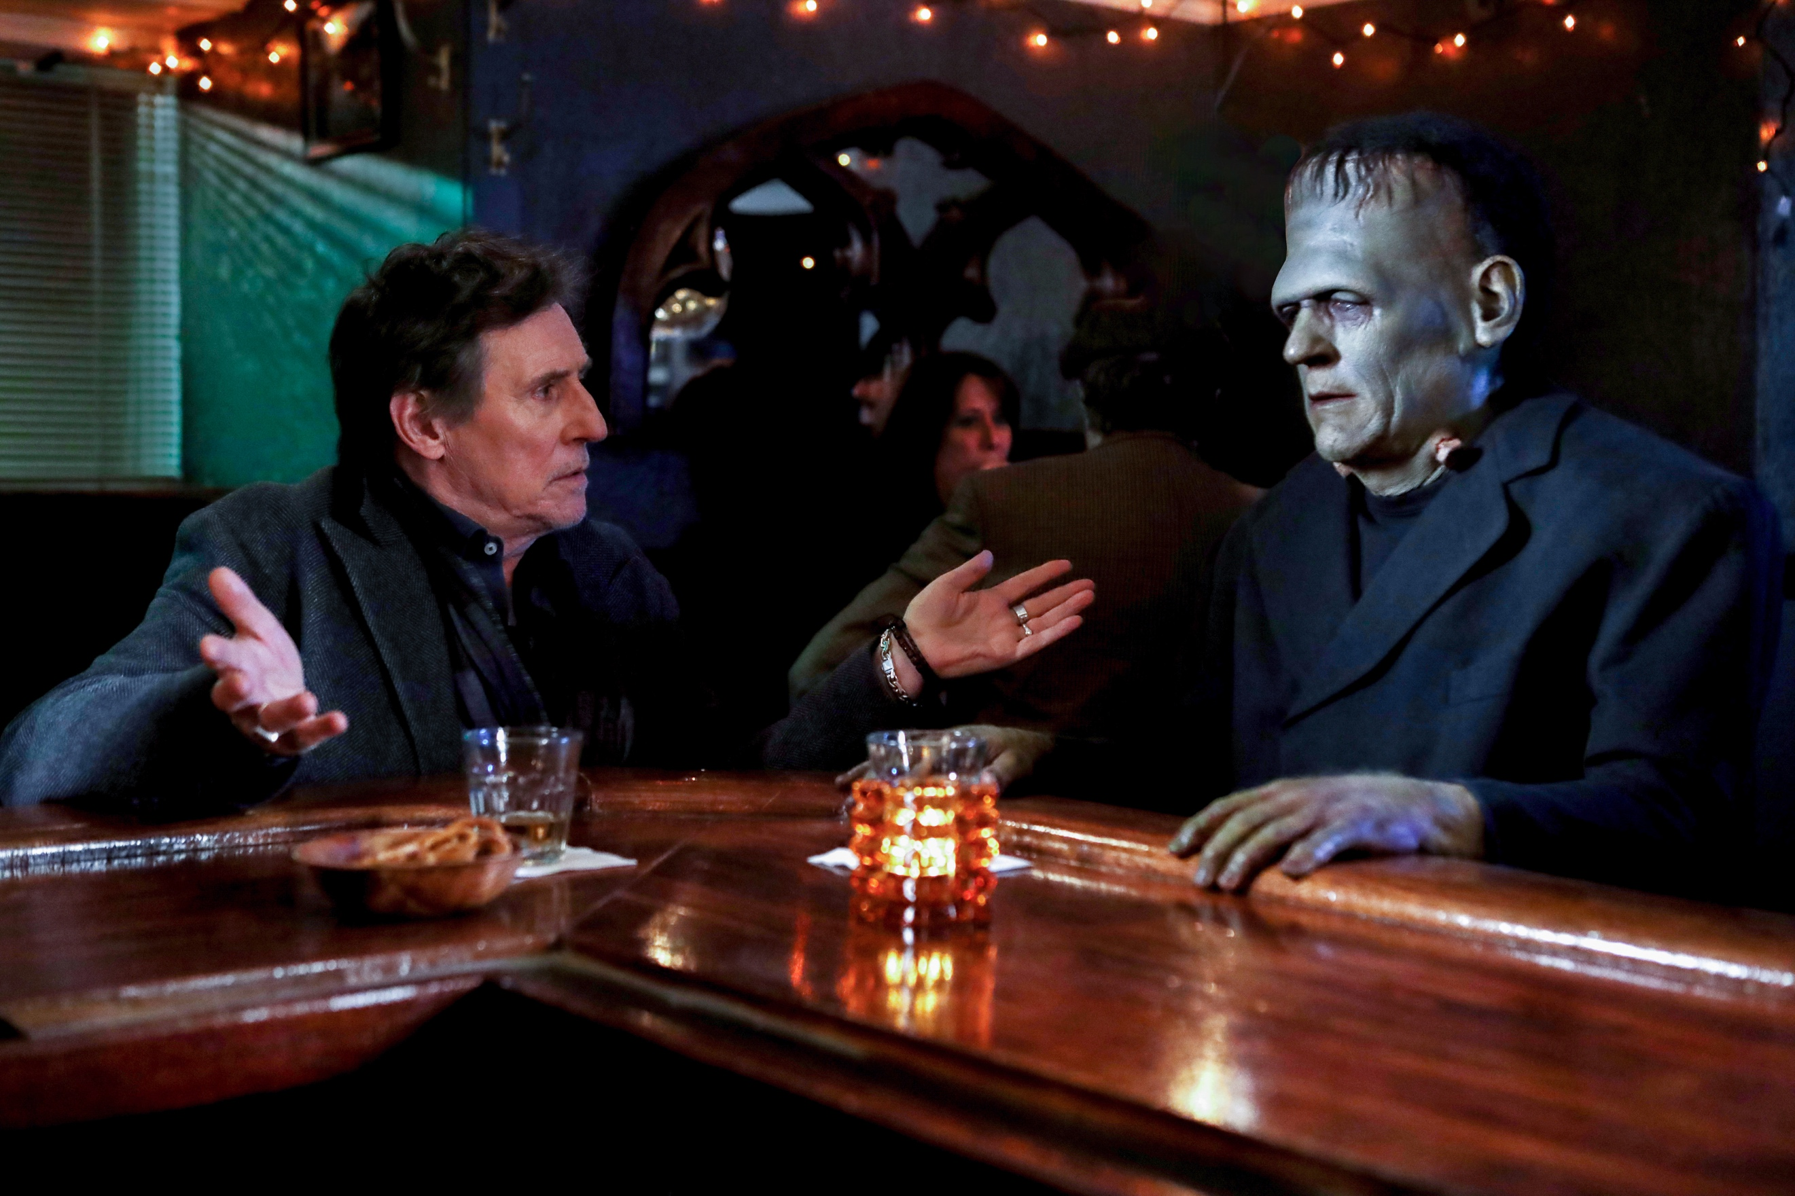

JURY FILM AWARDS

BEST FEATURE FILM: DRAMA
Death of a Ladies’ Man
Director: Matt Bissonnette
Producers: Corey Marr, John Brady, Don Carmody, Aleksandr Kushaev, Matina Niland, Marie-Claude Poulin

BEST FEATURE FILM: COMEDY
Pretenders
Director: Tristen Stafford
Producers: James Canellos, Adam Gale

BEST FEATURE FILM: DOCUMENTARY
Anchor Point
Director: Holly Tuckett
Producers: Holly Tuckett, Jennifer Dobner, Maddy Purves

SPECIAL JURY AWARD: DOCUMENTARY
Non Western
Director: Laura Plancarte
Producers: LP Films, TV UNAM, & The Montana Film Office

BEST HORROR, THRILLER, SCIENCE FICTION FEATURE FILM
A Beautiful Curse
Director: Martin Garde Abildgaard
Producer: Rikke Katborg

VISIONARY AWARD
Beneath the Banyan Tree
Director: Nani Li Yang
Producers: Nani Li Yang, Troy Chiu, Yue Wang

GLOBAL VISION AWARD
The First Death of Joana
Director: Cristiane Oliveira
Producers: Aleteia Selonk, Cristiane Oliveira

BEST TELEVISION PILOT
Parked in America
Director: Luke Salin
Producers: Cole Bannick, Jori Johnson, Alexandro Pacheco, Ann Swenson

BEST SHORT FILM: DRAMA
Americanized
Director: Erica Eng
Producer: Simran Mahal

BEST SHORT FILM: COMEDY
Je Suis Ton Pére
Director: Justine Le Pottier
Producer: Alexandre Dohan

BEST ANIMATED SHORT FILM
Footsteps on the Wind
Directors: Maya Sanbar, Faga Melo, Gustavo Leal
Producers: Gillian Gordon, Fernanda Zaffari

BEST FAMILY SHORT FILM
Stairs
Director: Zoljargal Purevdash
Producer: Genevieve Clay-Smith

BEST HORROR, THRILLER, SCI-FI SHORT FILM
While We Stayed Home
Director: Gil Vesely
Producer: Gil Vesely

BEST DOCUMENTARY SHORT FILM
Lion on the Mat
Director: Asali Echols

BEST STUDENT SHORT FILM
Greta
Director: Sofie Verweyen

AUDIENCE FILM AWARDS

AUDIENCE AWARDS, FEATURE COMEDY
One Moment
Director: Deirdre O’Connor
Producers: Deirdre O’Connor, Jodi Weiner

AUDIENCE AWARDS, FEATURE DRAMA
Last Night in Rozzie
Director: Sean Gannet
Producers: Ryan McDonough, Sean Gannet, Joseph Stephans, Kris Meyer, Andrew Cahill

Lune
Directors: Aviva Armour-Ostroff, Arturo Perez Torres
Producers: Aviva Armour-Ostroff, Arturo Perez Torres

AUDIENCE AWARDS, FEATURE DOCUMENTARY
A Sexplanation
Director: Alex Liu
Producer: Steven Flynn

AUDIENCE AWARDS, FEATURE THRILLER, HORROR, OR SCI-FI
Slapface
Director: Jeremiah Kipp
Producers: Mike Manning, Artisha Mann-Cooper, Joe Benedetto

AUDIENCE AWARDS, SHORT FILM
Americanized
Director: Erica Eng
Producer: Simran Mahal

Egg Party
Director: Kersti Bryan
Producers: Ashton Heyl, Claire Kennedy, Max Rothman, Dan Amboyer, Eric P. Berger

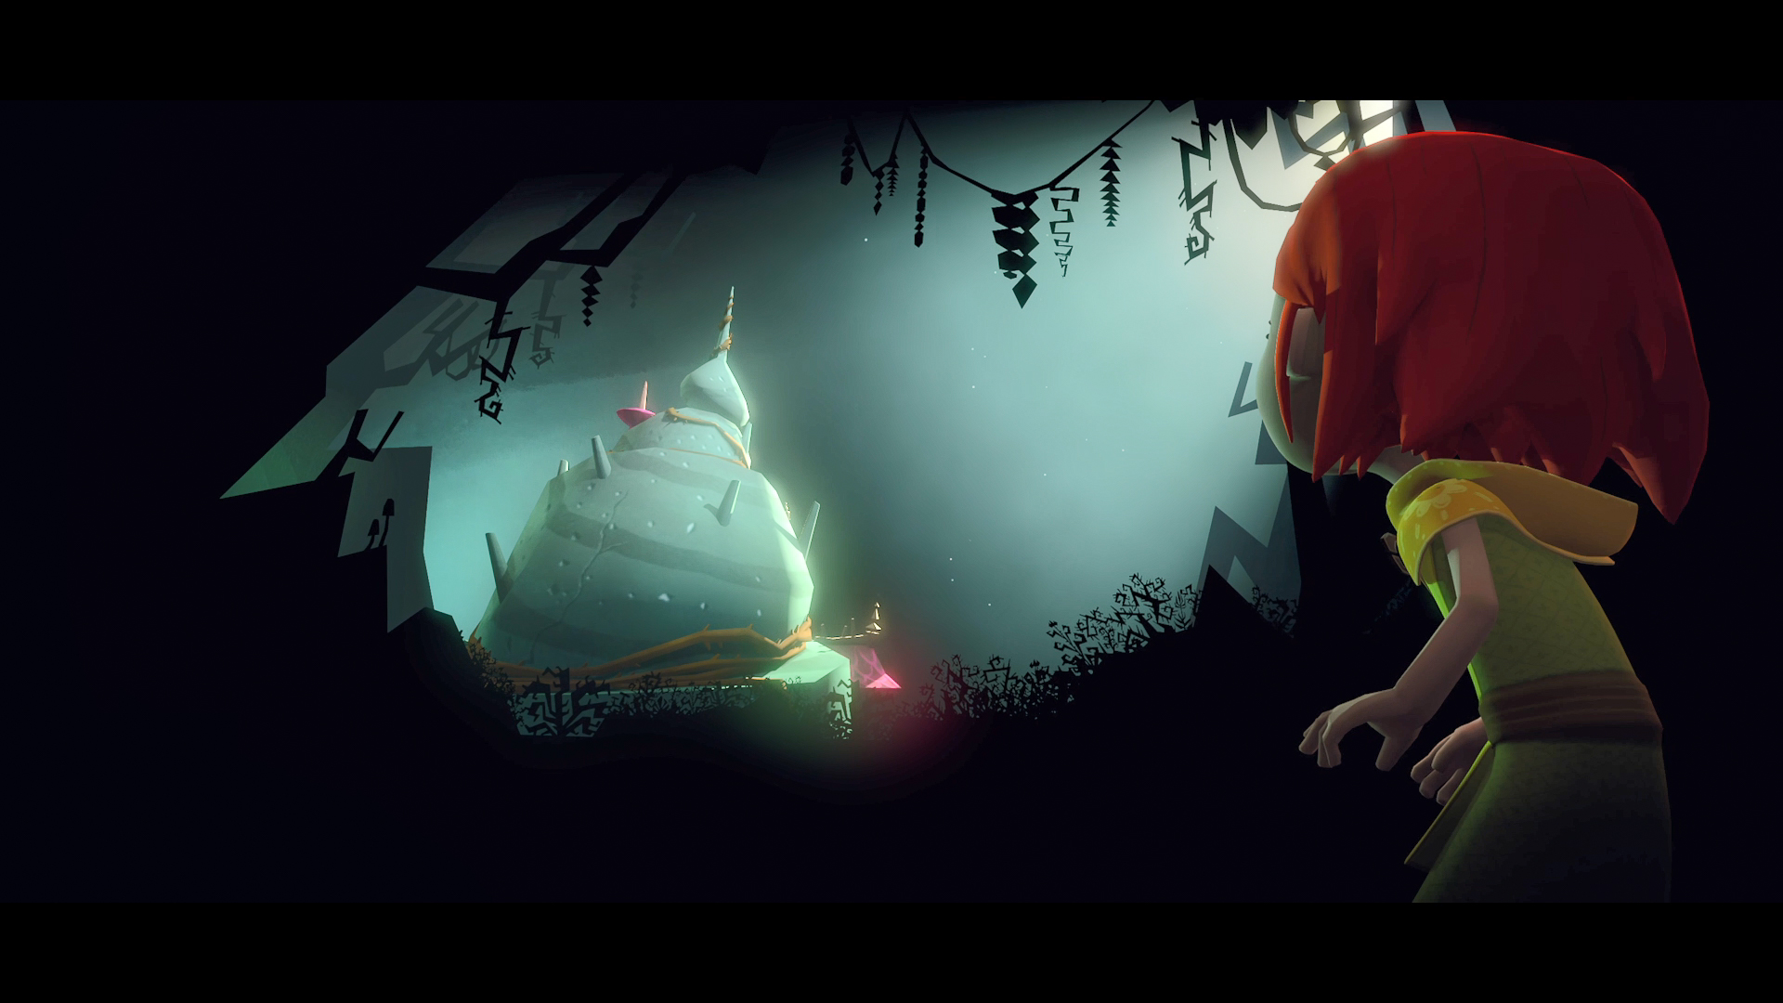

VR & AR AWARDS

BEST ANIMATION VR
In the Land of the Flabby Schnook

BEST IMMERSIVE VR
My Identity is the Expanse!

BEST STUDENT VR
Amends

BEST VR CINEMATOGRAPHY
Ecosphere

BEST DOCUMENTARY/EMPATHY VR
Replacements

BEST VR EXPERIENCE
Baba Yaga

BEST VR GAME
Flow Weaver

BEST VR MOVIE
People to People

BEST VR SCI-FI
Odyssey 1.4.9

BEST VR SOUND DESIGN
Nightsss

BEST VR STORYTELLING
Don’t Forget Me

MOST CREATIVE VR
The Vanishing American Dream

MOST INNOVATIVE VR
Micro Monsters with David Attenborough

SCREENWRITING WINNERS & FINALISTS

FEATURE FINALISTS
WINNER: Rise Up Little Girl by Matthew J. Avant
2nd: Swing And A Miss by Barbara Thornton
3rd: Aphrodite & The Apocalypse by Stacie Gancayco-Adlao
Queen of Newburgh by Lisa Cole & Veronica Moody
Icky People by Blaire Baron
The Big D by Michael Weinreb
4 Fine Women by Keith Planit
Bird’s Eye by Erin Beute
Salt West by Samuel Ripley Peirce
Brave Woman by Melissa Duges Spiers

SHORT-FILM FINALISTS
WINNER: Answers by Scott Tinkham
2nd: Feliz Navidad by Edward Tyndall
3rd: Mothership by Brianne Berkson
Bad Reception by Louise Lonergan
Libra by Matt Seroski
De Pachanga by Juan Carlos Sanchez & Richard Rennie
The 45th Annual Model United Nations All-Star All-School Conference by Zoe Maltby
Ravens by Patrick Gamble
Far From the Olive Grove by Andrea Land
Kingmaker by Bradley Coburn

TELEPLAY 60-MINUTE FINALISTS
WINNER: Drafting by Carol Faw
2nd: The Shadow King by Chris A. Bolton
3rd: Ex Humana by Helena Zhen
Breakaway by Tom O’Brien
Acceptance by Nick Childress and Jesse Eisenhardt
Land of Eagles by Isaac Banuelos
Under Cover of Darkness by Paul Raasch
Everything’s Fine by Cole Goslee
The Bliss Killer by LeLe Park
Highland Drive by Rosalyn Rosen

TELEPLAY 30-MINUTE FINALISTS
WINNER: Rise of the Immortals by Alan Sim
2nd: Wild Life by Carmiel Banasky
3rd: Wheels of Government by Mary Kay Holmes & Jeanette Scherrer
Ether 101 – The Handshake by Sabina Petra
Standard, Nebraska by Edward Hamel
Sous Weed by Joel Handler
Trivial by Rob Salerno
Love Lives by Allyson Morgan
BUDS by Alexis Aurigemma
The Killer B’s by Dave Chan

About Cinequest:
Cinequest fuses innovation with the arts to empower great creations and to connect audiences, youth, artists, and innovators with these creations and with each other—forging community, joy, and our future. Set in Silicon Valley, Cinequest’s uniqueness, impact, and legacy result from applying this powerful integration of creativity and technology to democratize opportunity and to transform lives. Cinequest does this through the Cinequest Film & Creativity Festival, Mavericks Studio, and Picture The Possibilities global youth programs.

Experience the JOY of cinema, artists, and community! Much more than a movie, CINEJOY is an online experience that brings you film and live events through a community and platform designed for discovery and engagement. CINEJOY, featuring the Artists and Movies of CINEQUEST, occurs March 20-30!

CINEJOY is hosted on the CREATICS platform that requires a quick, free registration that doubles as your registration and login when you purchase tickets to CINEJOY movies, events, and offerings.

Cinequest CINEJOY March 2021 Partners (partial list)

TJ & Valeta Rodgers, Clos De La Tech, Jennifer Krach, James Boyce Trust & Kris Otis, Eddie Lira, The Wolff Family, Applied Materials (NASDAQ: AMAT), ZOOM (NASDAQ: ZM), Tito’s Handmade Vodka, The Knight Foundation, Hint Water, Agile Ticketing Solutions, SV Creates, The Morrison & Foerster Foundation, and the City of San Jose.
###

