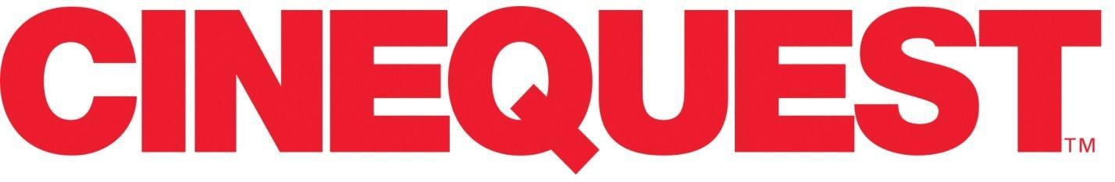
FOR IMMEDIATE RELEASE: Contact: Angela Ostermeier
December 10, 2021 E-mail: publicity@cinequest.org

CINEQUEST 2022 DATES
Cinequest 2021 Wrap
A year of Innovation and Elevating
Virtual Experiences for Artists and Audiences
December 10, 2021 (Silicon Valley)—Cinequest wraps a year of delivering exciting virtual events and experiences via its Cinejoy online platform. Cinequest delivered over 300 premiere films plus 200 live and interactive events and parties, serving global audiences from 58 countries. Cinequest announces 2021 Award Winners and the 2022 In-person and Virtual dates.
CINEQUEST IN-PERSON AND VIRTUAL EVENTS IN 2022
- Cinequest's In-Person Festival returns to the Silicon Valley August 16-28, sporting an exciting new summer format designed to provide an electrifying celebration of film, media-tech, and community.
- Cinejoy featuring the Artists & Movies of Cinequest will occur virtually April 1-17 and in the Fall and will feature new experiences to enhance the humanity and excitement of online events.

CINEQUEST 2021 HIGHLIGHTS & AWARDS:

- Cinequest’s sister company, Creatics ,with a team of Silicon Valley UX-UI designers and global engineers, built an exciting new platform to support all forms of creativity. In March of 2021, the first experience launched, the alpha of the online edition of the Cinequest Festival, called CINEJOY Alpha 1, featuring 199 Films (including 111 World & U.S. Premieres), Virtual Red Carpets, Industry Panels, Technology Showcases, and Celebrations. In November 2021, CINEJOY Alpha 2, featured over 187 Showcase films, shorts, and pilots, 13 Spotlight films with short film premieres, red carpets, and screening parties. Overall, we saw audiences and artists join us from all 50 states and 58 countries.
- Cinequest’s Maverick Spirit Award, its highest honor, recognized Artists, Innovators, and people who step outside the bounds of the normal to take risks and create something special. 2021 guest recipients included: Sam Neill, Eddie Izzard, and Darren Star.
- 2021 included empowering conversations with special guests including Rosario Dawson, Lee Daniels, Katie Couric, Andra Day, Troian Bellisario, Teagan Croft, Mena Suvari, Alec Baldwin, Thomas Jane, and many more!

PLEASE CHECK OUT THE CINEJOY HIGHLIGHTS VIDEO

CINEQUEST 2021 AWARDS:
Cinequest is thrilled to announce the 2021 Festival Awards for Films, Shorts, Television, VR/AR and screenplays.
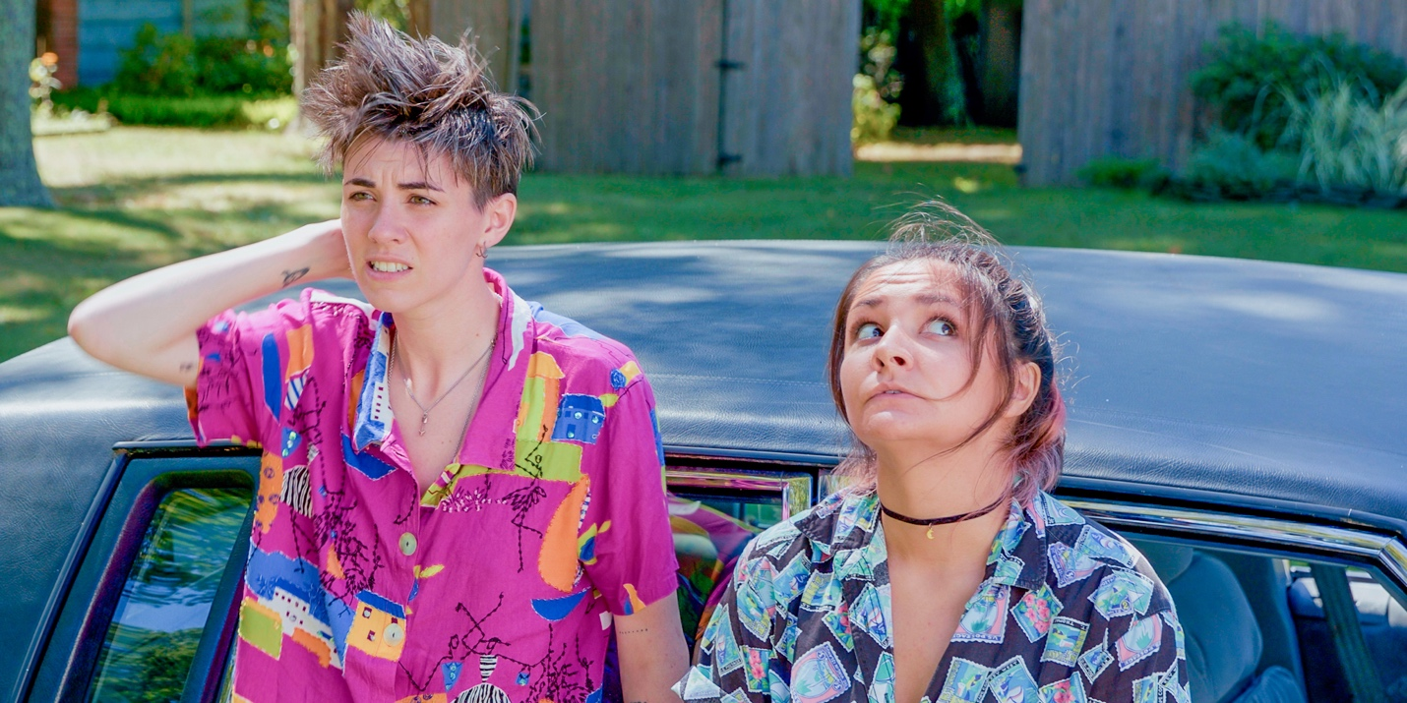
JURY FILM AWARDS
BEST FEATURE FILM: DRAMA
Death of a Ladies’ Man
Director: Matt Bissonnette
Producers: Corey Marr, John Brady, Don Carmody, Aleksandr Kushaev, Matina Niland, Marie-Claude Poulin
See You Then
Director: Mari Walker
Producers: Matt Miller, Mia Schulman, Kristen Uno, Mari Walker
BEST FEATURE FILM: COMEDY
Pretenders
Director: Tristen Stafford
Producers: James Canellos, Adam Gale
Reboot Camp
Director: Ivo Raza
Producers: David Lipper, Tina Sutakanat
BEST FEATURE FILM: DOCUMENTARY
Anchor Point
Director: Holly Tuckett
Producers: Holly Tuckett, Jennifer Dobner, Maddy Purves
Soy Cubana
Directors: Jeremy Ungar, Ivaylo Getov
Producer: Robin Miller Ungar
SPECIAL JURY AWARD: DOCUMENTARY
Non Western
Director: Laura Plancarte
Producers: LP Films, TV UNAM, & The Montana Film Office
BEST HORROR, THRILLER, SCIENCE FICTION FEATURE FILM
A Beautiful Curse
Director: Martin Garde Abildgaard
Producer: Rikke Katborg
Silent River
Director: Chris Chan Lee
Producers: Chris Chan Lee, Robert Cho, West Liang
VISIONARY AWARD
Beneath the Banyan Tree
Director: Nani Li Yang
Producers: Nani Li Yang, Troy Chiu, Yue Wang
The Sleeping Negro
Director: Skinner Myers
Producers: John Campbell, Matt Palmieri, Dan Funes, Alex Noel McCarthy, Skinner Myers
GLOBAL VISION AWARD
Landless
Director: Touraj Aslani
Producer: Touraj Aslani
The First Death of Joana
Director: Cristiane Oliveira
Producers: Aleteia Selonk, Cristiane Oliveira
BEST TELEVISION EPISODE
Parked in America
Director: Luke Salin
Producers: Cole Bannick, Jori Johnson, Alexandro Pacheco, Ann Swenson
Parent's Committee
Director: Michail Polyakov
Producers: Vyacheslav Murugov, Fyodor Bondarchuk, Anton Fedotov
BEST SHORT FILM: DRAMA
Americanized
Director: Erica Eng
Producer: Simran Mahal
Shut Up
Director: Noa Aharoni Maor
Producer: Dafna Danenberg
BEST SHORT FILM: COMEDY
Je Suis Ton Pére
Director: Justine Le Pottier
Producer: Alexandre Dohan
Navel Gazers
Director: Kimmy Gatewood
Producers: Lauren Bancroft, Kimmy Gatewood, Matthew C. Johnson, Annie Mebane, Devin Doyle
BEST ANIMATED SHORT FILM
Footsteps on the Wind
Directors: Maya Sanbar, Faga Melo, Gustavo Leal
Producers: Gillian Gordon, Fernanda Zaffari
Thanadoula
Director: Robin McKenna
Producers: Robin McKenna, Jelena Popovic
BEST FAMILY SHORT FILM
Stairs
Director: Zoljargal Purevdash
Producer: Genevieve Clay-Smith
The Important Day
Director: Olesia Aleinikova
BEST HORROR, THRILLER, SCI-FI SHORT FILM
While We Stayed Home
Director: Gil Vesely
Producer: Gil Vesely
You Will Never Be Back
Director: Mónica Mateo
Producer: Mónica Mateo
BEST DOCUMENTARY SHORT FILM
Lion on the Mat
Director: Asali Echols
Voice Above Water
Director: Dana Frankoff
Producers: Dana Frankoff, Eric Ebner
BEST STUDENT SHORT FILM
Greta
Director: Sofie Verweyen
This River
Director: Naomi Fryer
Producers: Naomi Fryer, Katherine Shearer
BEST MUSIC VIDEO
Ghost Girl
Director: Christopher Kezelos
Producer: Christine Kezelo
AUDIENCE FILM AWARDS
AUDIENCE AWARDS, FEATURE COMEDY
One Moment
Director: Deirdre O’Connor
Producers: Deirdre O’Connor, Jodi Weiner
AUDIENCE AWARDS, FEATURE DRAMA
Last Night in Rozzie
Director: Sean Gannet
Producers: Ryan McDonough, Sean Gannet, Joseph Stephans, Kris Meyer, Andrew Cahill
Lune
Directors: Aviva Armour-Ostroff, Arturo Perez Torres
Producers: Aviva Armour-Ostroff, Arturo Perez Torres
AUDIENCE AWARDS, FEATURE DOCUMENTARY
A Sexplanation
Director: Alex Liu
Producer: Steven Flynn
AUDIENCE AWARDS, FEATURE THRILLER, HORROR, OR SCI-FI
Slapface
Director: Jeremiah Kipp
Producers: Mike Manning, Artisha Mann-Cooper, Joe Benedetto
AUDIENCE AWARDS, SHORT FILM
Americanized
Director: Erica Eng
Producer: Simran Mahal
Egg Party
Director: Kersti Bryan
Producers: Ashton Heyl, Claire Kennedy, Max Rothman, Dan Amboyer, Eric P. Berger

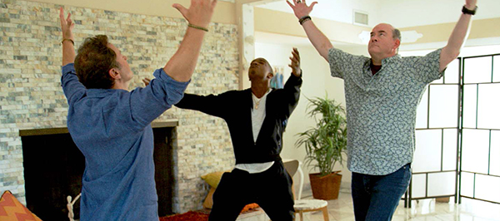

VR & AR AWARDS
BEST ANIMATION VR
In the Land of the Flabby Schnook
BEST IMMERSIVE VR
My Identity is the Expanse!
BEST STUDENT VR
Amends
BEST VR CINEMATOGRAPHY
Ecosphere
BEST DOCUMENTARY/EMPATHY VR
Replacements
BEST VR EXPERIENCE
Baba Yaga
BEST VR GAME
Flow Weaver
BEST VR MOVIE
People to People
BEST VR SCI-FI
Odyssey 1.4.9
BEST VR SOUND DESIGN
Nightsss
BEST VR STORYTELLING
Don’t Forget Me
MOST CREATIVE VR
The Vanishing American Dream
MOST INNOVATIVE VR
Micro Monsters with David Attenborough
SCREENWRITING WINNERS & FINALISTS
FEATURE FINALISTS
WINNER: Rise Up Little Girl by Matthew J. Avant
2nd: Swing And A Miss by Barbara Thornton
3rd: Aphrodite & The Apocalypse by Stacie Gancayco-Adlao
Queen of Newburgh by Lisa Cole & Veronica Moody
Icky People by Blaire Baron
The Big D by Michael Weinreb
4 Fine Women by Keith Planit
Bird’s Eye by Erin Beute
Salt West by Samuel Ripley Peirce
Brave Woman by Melissa Duges Spiers
SHORT-FILM FINALISTS
WINNER: Answers by Scott Tinkham
2nd: Feliz Navidad by Edward Tyndall
3rd: Mothership by Brianne Berkson
Bad Reception by Louise Lonergan
Libra by Matt Seroski
De Pachanga by Juan Carlos Sanchez & Richard Rennie
The 45th Annual Model United Nations All-Star All-School Conference by Zoe Maltby
Ravens by Patrick Gamble
Far From the Olive Grove by Andrea Land
Kingmaker by Bradley Coburn
TELEPLAY 60-MINUTE FINALISTS
WINNER: Drafting by Carol Faw
2nd: The Shadow King by Chris A. Bolton
3rd: Ex Humana by Helena Zhen
Breakaway by Tom O’Brien
Acceptance by Nick Childress and Jesse Eisenhardt
Land of Eagles by Isaac Banuelos
Under Cover of Darkness by Paul Raasch
Everything’s Fine by Cole Goslee
The Bliss Killer by LeLe Park
Highland Drive by Rosalyn Rosen
TELEPLAY 30-MINUTE FINALISTS
WINNER: Rise of the Immortals by Alan Sim
2nd: Wild Life by Carmiel Banasky
3rd: Wheels of Government by Mary Kay Holmes & Jeanette Scherrer
Ether 101 – The Handshake by Sabina Petra
Standard, Nebraska by Edward Hamel
Sous Weed by Joel Handler
Trivial by Rob Salerno
Love Lives by Allyson Morgan
BUDS by Alexis Aurigemma
The Killer B’s by Dave Chan
About Cinequest: Cinequest fuses innovation with the arts to empower great creations and to connect audiences, youth, artists, and innovators with these creations and with each other—forging community, joy, and our future. Set in Silicon Valley, Cinequest’s uniqueness, impact, and legacy result from applying this powerful integration of creativity and technology to democratize opportunity and to transform lives. Cinequest does this through the Cinequest Film & Creativity Festival, Mavericks Studio, and Picture The Possibilities global youth programs.
Experience the JOY of cinema, artists, and community! Much more than a movie, CINEJOY is an online experience that brings you film and live events through a community and platform designed for discovery and engagement.
Cinequest CINEJOY March 2021 Partners (partial list)
TJ & Valeta Rodgers, Clos De La Tech, Jennifer Krach, Ramona Reichl, James Boyce Trust & Kris Otis, Eddie Lira, The Wolff Family, Applied Materials (NASDAQ: AMAT), Kaiser Permanente, ZOOM (NASDAQ: ZM), Tito’s Handmade Vodka, Chan Zuckerberg Initiative, Hint Water, Agile Ticketing Solutions, SV Creates, The Morrison & Foerster Foundation, NBC Bay Area, Telemundo 48, iHeartMedia, El Observador, Metro, Yelp South Bay, the City of San Jose, and Redwood City Arts Commission.

###

